|  |  |  |  |  |
| --- | --- | --- | --- | --- |
| Products | Language | Description |  |  |
| Device --> azure IOTHUb à azure streaming analytics --> DB | Python/Json |  |  |  |
| Cleint UI à azure function à Device | Nodejs/Json |  |  |  |

Parts Used in Designing Covid Analyser:

1. HDMI screen display
2. Compact Microphone
3. Raspberry Pi 3B+ ,
4. Sdcard 32GB
5. Battery charger for pi
6. MAX30100 Heart rate detector sensor
7. GY-906 BCC IR based contactless temperature sensor
8. Speaker : Prefer [Grove - Speaker - Seeed Studio](https://www.seeedstudio.com/Grove-Speaker-p-1445.html?gclid=CjwKCAiAxKv_BRBdEiwAyd40N3I4zOVSxNYApDU9DyR53TRsG2Je3aWfupsivzGLAObn4x6fTrID2xoCD-0QAvD_BwE)

Steps to follow for raspberry Pi configuration Setup:

1. Insert the micro SD card in reader and insert the reader in PC, format the Sd card
2. Download the Noobs zip from the following link:
3. https://www.raspberrypi.org/downloads/noobs/
4. Extract the zip file in the SD card folder
5. Remove the SD card and insert it in the SD card slot of Raspberry PI.
6. Connect Raspberry Pi with PC by connecting keyboard, HDMI, ethernet port
7. Power up the Raspberry Pi using any adapter
8. Turn on your computer
9. Select Raspbian from the prompted option to install the OS and click install
10. It will reboot the pi

Reference link: <https://www.youtube.com/watch?v=8-RpnGfY7YU>

1. For further part follow this tutorial [How to Setup Raspberry Pi Without Monitor and Keyboard : 7 Steps - Instructables](https://www.instructables.com/How-to-Setup-Raspberry-Pi-Without-Monitor-and-Keyb/)
2. Open up Putty and type in the IP address of your Pi and connect. 'pi' & 'raspberry' is the default 'login as' and 'password' in Raspbian.
3. It is always a good practice to Update and Upgrade the system as soon as you log in. To do it, type in the command 'sudo apt-get update' and 'sudo apt-get upgrade' one at a time.
4. Get Pi in Desktop mode through hdmi monitor or VNC viewer,
5. Command sudo apt-get install python-smbus python3-smbus python-dev python3-dev in terminal
6. Run the following command to install i2c-tools in pi:

sudo apt-get install i2c-tools

1. Enable I2C, camera,GPIO and SPI in “raspi-config” by following this document [Raspberry Pi SPI and I2C Tutorial - learn.sparkfun.com](https://learn.sparkfun.com/tutorials/raspberry-pi-spi-and-i2c-tutorial/all)

Parts Connection To Pi 3B+

Follow the pinout of pi,

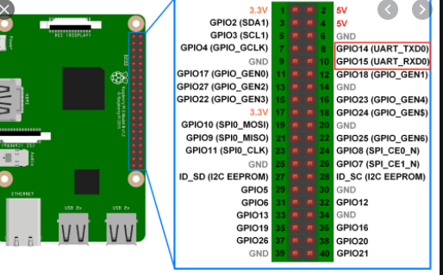

For sensors connection:

Max30100 ESP (heartrate Detection)

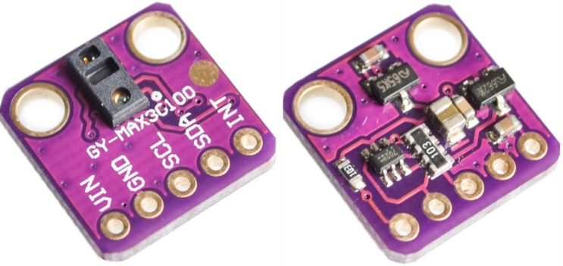

mlx90614 (body Temperature Sensor)

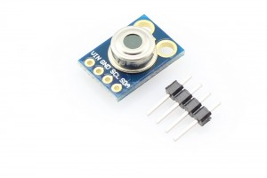

* connection PINS GPIO and sensor max30100

(3.3V -VIN)

(I2C SDA1 - SDA)

(I2C SCL1 - SCL)

(PIN7 - INT )

(GND - GND)

* connection PINS GPIO and sensor mlx90614

(3.3V -VIN)

(I2C SDA1 - SDA)

(I2C SCL1 - SCL)

(GND - GND)

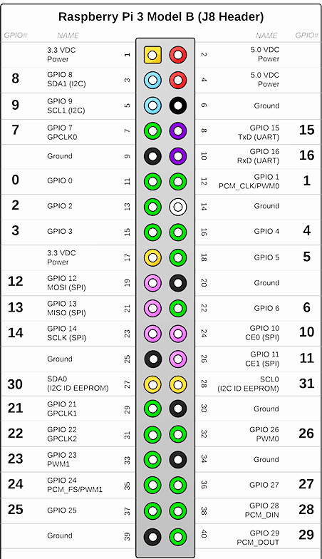

Veify whether the sensors are connected :

By running command like i2cdetect -y 1 in terminal, if everything goes well, you will see 57 and x5 as device address as shown below: ** while running this command, u will be needed to keep your finger on heart rate sensor.

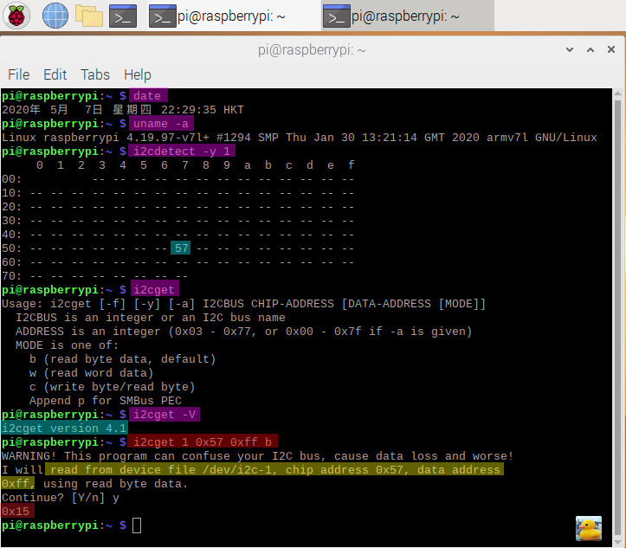

Further setups for miniMicrophone:

* To see all the available recording devices, we need to run the following command.

arecord -l

you will see card and device number for the default microphone device

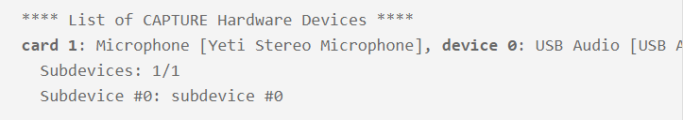

With our device and card numbers now handy, let’s go ahead and create a configuration file for Alsa.

This configuration file will help the Alsa driver understand what device it should be using for capturing audio.

Begin modifying the file by running the following command.

nano /home/pi/.asoundrc

Within this file, enter the following text.

Make sure that you replace [card number] and [device number] with the values you retrieved in step 3 of this section.

pcm.!default {

type asym

capture.pcm "mic"

}

pcm.mic {

type plug

slave {

pcm "hw:[card number],[device number]"

}

}

Once done, save the file by pressing CTRL + X, followed by Y, then ENTER.

Further setups for camera:

Load v412 driver:

sudo modprobe bcm2835-v4l2

First run raspi-config and enable the Pi to work with the [camera module](https://amzn.to/2pE5HWm):

$ sudo raspi-config

Select ‘5 - Interfacing Options’ and then ‘P1 Camera’. Enable the camera by highlighting ‘' and pressing enter.

No enable a module option to improve the camera modules picture quality.

$ echo 'options bcm2835-v4l2 gst_v4l2src_is_broken=1' | sudo tee -a /etc/modprobe.d/bcm2835-v4l2.conf

$ echo 'bcm2835-v4l2' | sudo tee -a /etc/modules-load.d/modules.conf

Reboot, and your Raspbery Pi Camera will be available within the browser: